

MATHEMATICS 3CMAT/3DMAT SAMPLE EXAMINATION

RESOURCE-FREE
Section 7 of the New WACE Manual: General Information 2006–2009 outlines the policy on WACE examinations.

Further information about the WACE Examinations policy can be accessed from the Curriculum Council website at http://newwace.curriculum.wa.edu.au/pages/about_wace_manual.asp.

The purpose for providing a sample examination is to provide teachers with an example of how the course will be examined. Further fine tuning will be made to this sample in 2007 by the examination panel following consultation with teachers, measurement specialists and advice from the Assessment, Review and Moderation (ARM) panel.

The examination is in two parts, in line with recommendations of the ARM panel--a resource-free examination of 50 minutes, worth 40 marks, and a resource-rich examination of 100 minutes, worth 80 marks. CAS (Computer Algebra System) calculators are excluded in the resource-free part and included in the resource-rich part.

0000.doc




Western Australian Certificate of Education, Sample External Examination
Question/Answer Booklet

MATHEMATICS
3CMAT/3DMAT
Please place one of your student identification labels in this box.
WRITTEN PAPER
RESOURCE-FREE

Student Number: In figures

In words

Time allowed for this paper
Reading time before commencing work: Five minutes
Working time for paper: Fifty minutes

Material required/recommended for this paper

To be provided by the supervisor
This Question/Answer Booklet

To be provided by the candidate
Standard items: Pens, pencils, eraser, correction fluid, highlighter

Important note to candidates
The standard items listed above and the Resource-free examination paper are the only items permitted on your table during the Resource-free examination. When directed, you will place all other items and the Resource-rich examination paper under your chair.

This paper is for students who have completed Units 3CMAT and 3DMAT as their last pair of units.
Structure of this paper

Working time | Number of questions available | Number of questions to be attempted | Marks
50 minutes | 5 | 5 | 40
 |  | [Total marks] | 40

This paper has FIVE (5) questions. Attempt ALL questions.

Question | Marks
1 | 7
2 | 6
3 | 8
4 | 7
5 | 12
Total marks | 40

Instructions to candidates

1. The rules for the conduct of Curriculum Council examinations are detailed in the Student Information Handbook. Sitting this examination implies that you agree to abide by these rules.

2. Write your answers in the spaces provided in this Question/Answer Booklet. Spare pages may be found at the end of the booklet. If you need to use them, indicate in the original answer space where the answer is continued (i.e. give the page number).

3. A blue or black ballpoint or ink pen should be used.

4. It is recommended that you do not use pencil except in diagrams.

5. Show all your working clearly. Your working should be in sufficient detail to allow your answers to be checked readily and for marks to be awarded for reasoning. Correct answers given without supporting reasoning may not be allocated full marks. Incorrect answers given without supporting reasoning cannot be allocated any marks. If you repeat an answer to any question, ensure that you cancel the answer you do not wish to have marked
RESOURCE-FREE

This paper has FIVE (5) questions. Attempt ALL questions.

Question 1 [7 marks]
Given 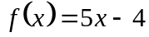,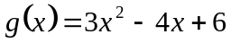 and 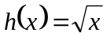 determine:

- 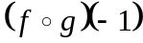
[2 marks]

- 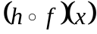
[1 mark]

- the domain and range of:

(i) f
[1 mark]

(ii) h
[1 mark]

(iii) 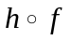
[2 marks]

Question 2 [6 marks]
- Determine 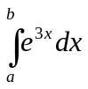
[2 marks]

- Show that 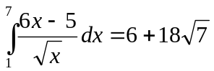
[4 marks]

Question 3 [8 marks]
The curve 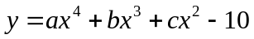 has a point of inflection at (-1,-1). The tangent to the curve at x = -2 is parallel to the line 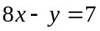. Find a, b and c by setting up a system of equations, then using an algebraic method to solve the system.
[8 marks]

Question 4 [7 marks]
- Simplify: 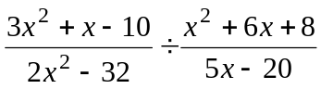
[3 marks]

- Solve: 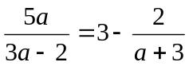
[4 marks]

Question 5 [12 marks]
A window is to be made in the shape of a rectangle surmounted by a semi-circle. The radius of the semi-circular section is y cm, the length of the rectangular section is x cm and the perimeter of the window is L cm.

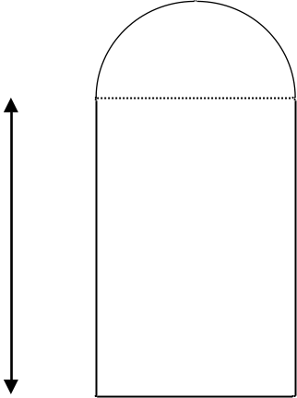
y
x

- Find L in terms of x and y. Hence show that 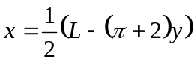 and deduce that 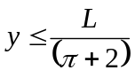
[3 marks]

- Show that the area A cm² of the window is given by
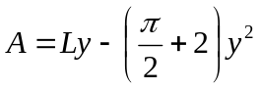
[4 marks]

- Show that, for a given L, the greatest possible area of the window is
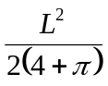
[5 marks]

ACKNOWLEDGEMENTS

Published by the Curriculum Council of Western Australia
27 Walters Drive
OSBORNE PARK WA 6017

